

These information sheets are written by **Dr John O'Bryen**. Neither he nor HealthCert Education take any responsibility for how these forms are used, and practitioners must ensure they modify these forms to suit their practice and seek independent advice.

**Patient Information Kit**

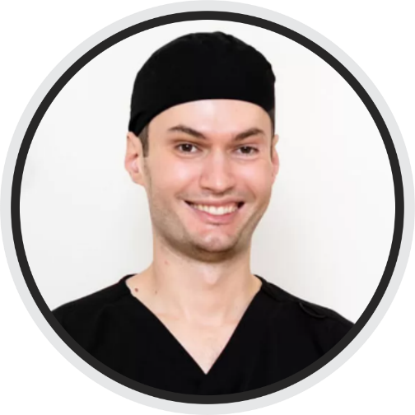

**These information sheets are**

**You can download a digital copy of**

**this kit by scanning this QR code:**

**www.bodyscanclinic.com.au**

**Your Skin Check Report**

If you want to see photos and videos of skin cancers to learn how to spot them, please see my social media account **@skincancerdoctor** on Instagram, Facebook or TikTok.

Your skin check score today = **A B C D E**

|  |  |
| --- | --- |
| **Okay** | **Bad** |
| Moles  Dysplastic naevi  Freckles  Angiomas (red dots)  Seborrhoeic keratoses “age spots”  Stucco keratoses  Solar lentigos “liver spots”  Sebaceous hyperplasia  Skin tags  Dermatofibromas  Epidermoid cyst  Idiopathic guttate hypomelanosis (white spots arms and legs)  Tinea/ringworm -> terbinafine 1% cream from the chemist  Seborrhoeic dermatitis -> Dercos from the chemist | Solar/actinic keratoses “sun spots” -> precancerous to SCC  Intraepidermal carcinoma (IEC) or Bowen’s disease -> thin less severe form of SCC  Squamous cell carcinoma (SCC)  Basal cell carcinoma (BCC)  Melanoma |

How to stay sun-safe

Ultraviolet (UV) radiation from the sun causes about 95% of all skin cancers. Check the daily UV forecast with an app such as the SunSmart app (free). Avoid the sun when the UV rating is above 3. Stay in the shade. Wear a wide brimmed hat, long and protective clothing to cover as much skin as possible, wear sunglasses, use SPF 50+ sunscreen to the skin which is exposed.

If you are exceptional at sun avoidance you may get vitamin D deficient and need to take a supplement. Usually we only need 8 minutes of sun per day to make adequate vitamin D. If you get lots of solar keratoses, BCCs and SCCs I suggest you take vitamin B3 (nicotinamide) 500mg once daily which confers a 25% future risk reduction. B3 in a cream form (called niacinamide) can be used on sun damaged skin with solar keratoses.

Does your blood pressure medication contain hydrochlorothiazide (HCT)? It can make you sunburn more easily and more likely to get solar keratoses, BCCs and SCCs. If so, discuss with your GP about switching.

**Biopsy site aftercare**

* You have had a skin biopsy performed to test for skin cancer.
* Caring for your wound is important to prevent infection and promote healing.
* Unless otherwise advised, keep the dressing on and dry for 1 to 2 days.
* Before removing the dressing, wet it first in the shower to reduce sticking.
* Afterwards, dry the site and then apply a bandaid.
* Change the bandaid daily until the site is dried and healed.

Please call us if you experience any of the following:

* Heavy or continual bleeding from the site (elevate the site and apply firm pressure for 15 minutes)
* Severe or increasing pain
* Fevers
* Increasing redness or tenderness
* Pus or discharge soaking through dressings
* Concern that stitches have broken (most biopsies won’t have stitches)

Follow-up of results following a biopsy or excision

* Doctor will let you know how to communicate results with you.
* If doing a phone call (will be bulk billed), please complete the bulk bill consent forms sent via HotDoc. If you do not complete these forms you will then be liable to pay a private fee for the phone call.
* If you are coming back for removal of stitches, we will advise you of results then.
* If you require an excision, you can use EMLA numbing cream to the site (although we find it doesn’t prevent all pain from local anaesthetic injections). EMLA is over the counter at pharmacies. Apply at least an hour before your excision time to the site including the surrounding skin about 5x5 cm total.

**Phone call** / **Come in person** / **Text**

Date: Time:

**Dressing and suture care**

* Keep dressing dry and intact for 48 hours unless instructed otherwise.
* After 48 hours, remove dressing, allow clean water to run over area when showering, then gently PAT dry.
* **NOTE:** If there is tape directly over the stitches, please leave this in place until your next visit / or until it comes off by itself. This tape can get wet in the shower and dabbed dry. This will help to protect your stitches against rubbing on clothing etc.

Pain

* Some discomfort following surgery may be experienced. Severe pain is uncommon.
* Paracetamol and/or Ibuprofen may be used as per directions on packaging.
* Ice packs can be used over the dressing.

Bleeding

* It is common to have some minor bleeding after surgery for the first 24 hours.
* If this happens please elevate and apply pressure for 15 minutes. Should bleeding persist, please notify our clinic. After hours, present to your nearest Emergency Department. To reduce your chances of bleeding following surgery please limit physical activity for the first 24 hours.
* Head/Neck surgery- Consider placing an old towel over your pillow to avoid getting blood on the pillow case.
* Limb surgery- Elevate limb as much as possible and avoid unnecessary walking. If you have a bandage over the area, keep this in place for 2 days.

Bruising & Swelling

* This is common following any surgical procedure.
* Surgery close to the eye may result in a "black eye". Swelling and bruising will slowly decrease over the next few weeks. It may also occur in other areas near where the surgery occurred.

Scarring concerns

* Silicon gel (eg: STRATADERM), or adherence tape over the wound to be used 3 months post stitch removal to help minimise scarring. Sun exposed scars should be protected (daily sunscreen) to avoid pigmentation changes. Laser treatment can aid healing and cosmetic appearance of scars. Laser can be started once stitches are removed.

Please notify us if you experience ANY of the following:

* Bleeding from site which doesn’t settle with pressure.
* Pain which is severe or increasing and not relieved with Paracetamol or Ibuprofen.
* Temperature above 38 degrees or chills.
* Redness around site that is spreading, increasing heat over wound or offensive discharge.

**There are no out of pocket consultation fees for wound checks or stitch removal.**

**Please do not hesitate to call us if you have any concerns with your wound.**

**If you have travelled away, we can send an e-script for antibiotics.**

**Please call first and do not turn up unannounced.**

**Ph: 07 5450 1222**

Your follow up appointment is ………………………………………………..

**Procedure Consent Form**

**Body Scan Skin Cancer Clinic**

5/86 Burnett Street. Buderim QLD 4556  
Ph: 07 5450 1222

|  |  |
| --- | --- |
| Full Name of Patient: | D.O.B: |
| Doctor Performing Procedure |  |
| Condition(s) and Location(s)  of Planned Excision(s) | * Basal Cell Cancer * Squamous Cell Cancer * Melanoma * Other: |
| Proposed Closure | * Direct * Flap * Graft |

What to expect

* You will have a scar. Your doctor can indicate the expected size and location of the scar. Scars may stretch and change over time. Some people develop prominent, thick or discoloured scars (hypertrophic or keloid scars) with unpredictable outcome and may need further treatment.
* Some pain and tenderness is expected. Usually this is easily relieved by paracetamol +/- ibuprofen and ice packs.

Risks / complications associated with your procedure may include

* Postoperative bleeding requiring you to attend the clinic or an emergency department
* Significant pain particularly with larger procedures on tender sites
* Wound infection requiring antibiotics and even hospitalisation
* Wound breakdown, poor or slow healing requiring weeks to months of wound care
* Incomplete clearance of the skin cancer requiring further treatment
* Future recurrence of the skin cancer even despite apparent good clearance
* Damage to underlying structures (eg. nerves, blood vessels, muscles), persisting numbness
* Allergic reaction to a product or medication used (eg. antiseptic, local anaesthetic, dressings)
* Skin grafts and flaps may fail to take partially or completely
* Skin grafts may not match surrounding skin colour and texture and even grow hair

Additional risks specific to your procedure(s):

_____________________________________________________________________________

_____________________________________________________________________________

I acknowledge that my doctor has explained to me the treatment options for my condition, possible risks / complications of the procedure as well as risks of not having the procedure. I was given the opportunity to ask questions and raise concerns and they have been discussed and answered to my satisfaction.

I agree to comply with follow up reviews after the procedure as discussed with my doctor. (For patients with melanoma: 3 monthly for the first year, 6 monthly for the second year and yearly thereafter. For patients with non-melanoma skin cancers: 3 / 6 / 12 monthly depending on risk factors)

I request to have the procedure as described.

Fees

I am aware that I will be charged an out-of-pocket fee on top of a Medicare rebate. We only bulk bill eligible DVA card holders. I am aware that I will need to pay this full amount on the day of the procedure and then claim my Medicare rebate which can take several days to be received to my account.

I am aware that the out of pocket fee generally ranges from $200 - $500 however is subject to quotation by the doctor.

I am aware that the Medicare rebate is dependent on the Medicare item used. The Medicare item used is often not known until on the day of the procedure, because it is dependent on the size of excision, location of excision, type of lesion being excised, and type of closure used (direct, flap, graft). Sometimes the Medicare item used will not be known until I return for wound review / removal of stitches, and I will be asked to make payment at this visit.

I am aware of other healthcare provider options for receiving treatment. This includes referral to a public hospital, referral to a private surgeon, or approaching a suitable general practitioner.

Signature of Patient: Date:

________________________________ __________________________

Signature of Doctor:

________________________________

**Topical fluorouracil with gladwrap occlusion, also known as “chemowraps”**

Solar keratoses are pre-cancerous and can become squamous cell carcinoma. Your doctor has identified severe areas of solar keratoses on your body. These areas are prone to growing skin cancers. You are likely familiar with use of topical fluorouracil cream (brand name Efudix but there is a generic available now). Fluorouracil remains the cheapest and most effective treatment for solar keratoses. It is also effective against in situ squamous cell carcinoma. The typical use of this cream, is it to be rubbed onto the skin like a moisturiser and allowed to dry in. A more effective way of using the cream, reserved for people with severe field solar keratoses, is to apply the cream liberally and then gladwrap over it. This prevents the cream from being rubbed off, and it helps the cream penetrate deeper and get greater absorption. This results in a greater reaction and clearance. This treatment is most frequently used on the lower arms and legs.

**What is involved**

* You will need to provide the fluorouracil cream. Your doctor will provide you with a script containing repeats for more. Bring the cream to your appointments. Have a shower just before your first appointment.
* The nurse will apply the cream over the treatment area, then gladwrap, then place a stocking or bandage over the top to secure the gladwrap in place.
* You are to keep the wrap in place and dry for 2 nights. The next morning you will remove the wrap, enjoy a full shower and gently wash the treatment area.
* You will then return for you next application. Please bring the stocking or bandage for reuse if it is clean.
* There are many variations on how the applications are timed. I generally do it as six applications done on Monday, Wednesday and Friday for two weeks. However, this can be varied, for example, done on other days of the week, or applied twice a week for three weeks.
* Sometimes the treatment works quickly and your doctor will advise to cease treatment early. If your skin becomes too sore, or you are feeling unwell (symptoms such as headache, tummy cramps, diarrhoea, fever) please remove the wrap, wash off the cream, and discontinue further applications.
* I do not treat more than one limb at a time because of side effect risk.
* Each visit will be charged a consultation fee.
* You are welcome to do some of the applications at home but please discuss with me first.

**5-FLUOROURACIL 5% CALCIPOTRIOL 0.005% TRANSDERMAL CREAM**

Overview

Solar keratoses (sun spots) can become squamous cell carcinoma, a type of skin cancer. Solar keratoses are very common on sites repeatedly exposed to the sun, especially the face, the balding scalp, and the back of the hands and forearms. Cryotherapy (“freezing” or “dry icing”) is good for treating a small number of solar keratoses. However, when they are extensive, a topical field treatment is the best option. Previously, plain 5-FU (brand name Efudix) was a popular choice however the long treatment duration (2-4 weeks) and significant side effects limited its tolerability.

Calcipotriol in combination with 5-FU has demonstrated synergistic effects in optimally treating solar keratoses. The effects of this combination formula usually peak on days 10-11 after a twice daily treatment for 4 days without causing pain, crusting, or ulceration. This novel treatment has been carefully formulated and compounded by Artisan Chemist using advanced compounding technology. Milling of the raw ingredients (into ultra-fine particles) is achieved via Zirconia milling media and micronisation methods using the Maz Mixer (an advanced, patented compounding planetary mixer).

Precautions

Do not use if pregnant or breastfeeding.

Do not use if you have a known hypersensitivity to 5FU or calcipotriol or any of the excipients. Patients with dihydropyrimidine dehydrogenase (DPD) enzyme deficiency should avoid treatment. 5-FU is highly irritant, and so should not be allowed to come in contact with mucous membranes (eyes, inside of nostrils and mouth) due to the possibility of irritation, local inflammation and ulceration. While treatment is in progress, avoid cosmetics on treated areas and other topical medication applied to the same area, unless otherwise directed.

Exposure of treated skin to UV-radiation, (e.g. natural sunlight or tanning salon) must be avoided. This treatment is not advisable in persons who work outdoors for prolonged periods in the sun. Excessive sun exposure may produce a diffuse phototoxic response in the areas of application.If any occlusive dressing is to be used, there may be an increase in the severity of inflammatory reactions in the adjacent normal skin. A porous gauze dressing may be applied for cosmetic reasons without increase in reaction. Inflammatory skin conditions, e.g. rosacea—may worsen; treat the skin condition before starting treatment.

Administration

This treatment should only be used under medical supervision.  
  
Method of administration (How to use):

1. Wash the skin to be treated using lukewarm water. Avoid soap or other cleansing products which may sting or irritate your skin, especially as treatment progresses.
2. Pat dry the affected area with a soft white paper towel.
3. Allow 15 minutes for your skin to completely dry.
4. Apply a thin layer of cream to the affected area(s) twice a day, without a dressing, for 4 consecutive days only. Do not continue further unless advised by your doctor.
5. Use a non-metal applicator, cotton bud or a rubber glove to apply a thin film of cream, smoothing it gently onto your affected skin. Do not use too much cream.
6. Be very careful not to allow the cream to come into contact with mucous membranes, such as eyes, eyelids, nostrils and lips.
7. Do not apply to broken skin or open cuts as it is may be absorbed into the bloodstream and may cause side effects.
8. Wash your hands carefully and thoroughly immediately after using the cream.
9. Do not cover the treated area unless your doctor tells you to.

Use your medicine at about the same time each day. Apply in the morning and then again in the late afternoon or early evening. Do not apply the cream immediately before going to bed. Apply at least 1.5 - 2 hours before bedtime to enable complete absorption and prevent wiping off onto pillowcases and sheets. Contact with pillowcases or sheets may result in undesirable spreading of the cream to normal skin that does not need treatment.

After finishing the course of cream, you can then apply Vaseline jelly or La Roche-Posay Cicaplast or Avene Cicalfate to the skin for relief and to help with any peeling.  
  
The total area of skin treated with this preparation at any time should not exceed 500 square cm (approx. 23 x 23cm). Treat larger areas a section at a time.

Side effects

The most frequently encountered reactions are often related to an extension of the pharmacological activity of the medicine. These include pain, pruritus, hyperpigmentation, burning, crusting, allergic contact dermatitis, erosions, erythema, hyperpigmentation, irritation, photosensitivity, scarring, rash, soreness and ulceration at the site of application. Application site haemorrhage has also been reported. The patient should be advised of the temporary unsightly appearance and local discomfort to be expected during treatment with this drug.

Patients with chloasma and rosacea and other inflammatory dermatoses may encounter accentuation of their condition and should first be treated with appropriate therapy before using the medication. While absorption of 5-FU through healthy skin is negligible, absorption is considerably increased when it is applied to diseased skin. Infrequent adverse effects using this preparation are dizziness, stomach problems such as severe pain, cramps, bloody diarrhoea and vomiting, swelling and soreness of the mouth and tongue, fever and chills.

Storage

Keep the cream stored in the fridge, between 2-8°C. Protect from heat.  
Formulation can be stored outside of the fridge at Room Temperature for up to 48 hours without affecting stability. Keep all medicine out of the reach of children. Do not flush unused medications or pour down a sink or drain. Return any unused medicines to any community pharmacy, especially if it is past the expiry date.



www.artisanchemist.com.au

(07) 5443 4075

3/32 Production Av, Warana

**FLUOROURACIL 5% CALCIPOTRIOL 0.005% TRANSDERMAL CREAM**

**60 day expiry so don’t buy until you are ready to start treatment.**

**Pricing subject to change.**

5g = $59 10g = $78 20g = $97 50g = $174 100g = $243

Ordering your compound

Dr O’Bryen will usually send your script on the computer and you will receive a text message and email from the pharmacy within 24 hours. If you receive an original script, please email a copy to: **[info@artisanchemist.com.au](mailto:info@artisanchemist.com.au)** (including your mobile number). The pharmacy will then send you a link within 1 business day to confirm and process payment for your order. They will then notify you when your order is either ready for collection or has been express posted. All orders can take up to 2 business days to prepare.

Specific instructions from your doctor

You will be advised of where to use your cream. You should avoid treating more than 23 x 23 cm2 of skin (approximately an area covered by two hands) at a time. Large areas can be treated separately in sections.

|  |  |
| --- | --- |
| Face |  |
| Balded scalp |  |
| Back of right hand and forearm |  |
| Back of left hand and forearm |  |

Applying the cream to yourself is straightforward, however we recommend you come in and let myself or my nurse apply it to you for your first application. Please call to arrange a time for this and we will fit you in at short notice. (Bulk billed appointment)

It is recommended that you have your inflamed skin examined by a doctor, about 7-10 days after commencing the treatment. Please call to arrange a time to come in and we will fit you in at short notice. (Bulk billed appointment).

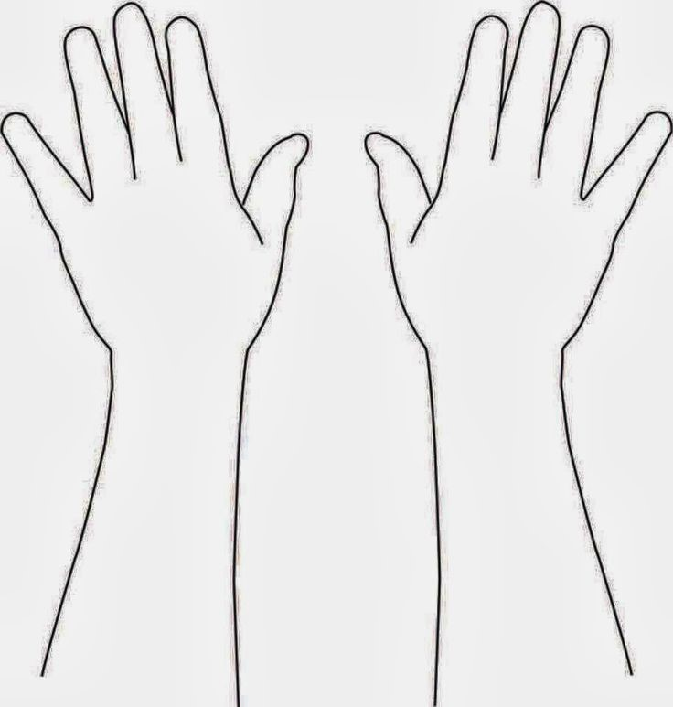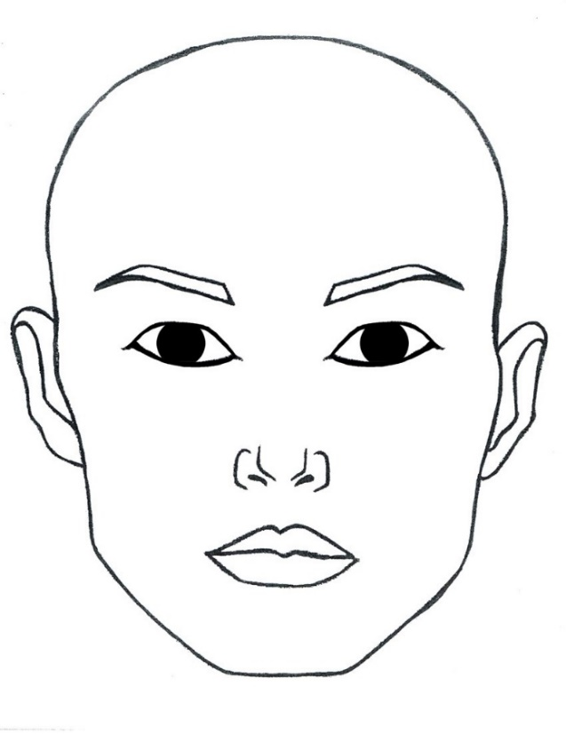

**Avoid the eyelids, lips, nostrils and grooves on the sides of the nostrils**

Daylight Photodynamic Therapy (dPDT)

Daylight Photodynamic Therapy (dPDT) is a simple non-invasive treatment used to treat pre-cancerous skin lesions (solar keratoses), and involves the application of a cream called 5-aminolevulinic acid (5-ALA), to the areas of concern. Commonly treated areas are the face, ears, balded scalp, bottom lip and the neck. It is not effective at treating other areas such as arms and legs. The cream binds to abnormal/mutant cells caused by sun damage. The natural daylight is then used to activate the cream and destroy the abnormal cells without harming the healthy skin. This treatment can be a gentler, quicker alternative to prolonged treatments such as Efudix (fluorouracil cream). **Do not do this treatment if you are pregnant or breastfeeding, or have a light sensitivity disorder**.

You book in with us to do the treatment. Please book in advance as we need a 15 minute consultation time. We provide the 5-ALA cream sourced from a compounding chemist. Do not apply makeup or sunscreen prior to coming in. We prepare the treated skin by first dermabrading it with ultra fine, sterilised sandpaper. We then apply a chemical (non-metal) sunscreen to the area. This will protect your skin from UV radiation (sunburn) without blocking the coloured sunlight which activates the 5-ALA. We then apply the 5-ALA to the skin. Careful to not touch or rub off the cream once applied.

You will be directed to go outside and expose the treated skin to natural light for 2 hours. Most people prefer to go home to do this. You should start the daylight exposure within 30 minutes of the 5-ALA being applied. The 2 hours begins when you get home and go outside so you will need to time this carefully. Avoid spending more than 2 hours outside as you may get a more severe reaction. Do not wear a hat or sunglasses if will shade treated areas. **Full sun exposure is desired** but you can retreat under partial shade for a break if needed. If it happens to rain, get under cover but remain outdoors, and add an extra 30 minutes to your 2 hour treatment time. Afterwards, the treated area needs to be washed clean with a soft cloth, soap and water, or in the shower. Then apply sunscreen and avoid any significant sun exposure. On the day, please wear suitable clothing that will keep the treated skin sun exposed. If you have long hair please bring a headband to keep your hair from shading your face. If your treatment day is expected to have significant rain and wind, your appointment will need to be postponed, we will call you as soon as we open to let you know.

After treatment

The treated area will have a sunburn appearance; redness, itching, peeling. This will usually subside after a few days but can **persist for up to 2 weeks** so please consider this when booking. Strong reactions with swelling, crusting and weeping can occur. If you are prone to cold sores, this treatment can bring them out and I can prescribe you an antiviral medication to take after treatment to prevent this. It is important to protect the treated area from any sunlight for the first **48** hours. Step 1 When you shower use gentle cleanser. Step 2 Moisturise your skin at least 3 x a day (if cream stings use petroleum jelly like Vaseline jelly or soothing balm like Cicaplast or Cicalfate) until it has healed Step 3 Apply SPF 50+ mineral sunscreen every morning to protect the treated skin from further sun exposure. We recommend a review with Doctor about 3 days after treatment. Advantan fatty ointment may be prescribed to hasten recovery if you have had a strong reaction. Skin can be retreated with PDT after 3 months if required.

Cost

Costis $380.00 (subject to change), with a small Medicare rebate item 23 or 36. You may get more back if you hit the Medicare safety net. This includes cost of the 5-ALA and any follow up visits required for the PDT. To Book this PDT treatment call the clinic 07 5450 1222 ask to book "daylight photodynamic therapy". Bookings will only be available between 8.30am - 2pm daily so that there is adequate time for sunlight exposure.

LED PDT

LED PDT is similar to daylight PDT except the 5-ALA cream is activated by 15 minutes of red or blue light from a powerful LED light machine. The pros include that it is not weather dependent and no sunscreen is needed. It can be used to treat areas of solar keratoses anywhere on the body, and it can also be used to treat some thin types of skin cancers (2 doses required). It can also be used for treatment of viral warts and acne. We use a XEN LED device which is medical grade and listed on the ARTG register. Cheap, cosmetic LED lights are typically weak and have variable dosing and are not suitable.

LED PDT can be used to treat the following types of skin cancer (a biopsy required)

* **Squamous cell carcinoma in situ / intraepidermal carcinoma / Bowen’s disease**
* **Superficial and thin nodular basal cell carcinoma**

The cure rate for these skin cancers is about 80%. If your cancer is not cured (doesn’t clear with treatment or grows back at a later stage) then surgical excision will be recommended.

Many people are comfortable to have their cancers cut out giving a >95% cure rate, and pathology results are provided and help confirm cure. LED PDT for skin cancer is usually attractive for people who want to avoid a surgical scar on a cosmetic area such as the face or upper chest.

Contraindications and precautions include:

Pregnancy, breastfeeding, light sensitive epilepsy, photosensitivity disorder, oral isotretinoin (3-6 month break prior), oral doxycycline (1-2 week break prior), topical Retin A / Retrieve / Tretinoin (1-2 week break prior).

What happens on the day

Do not apply any skincare products or makeup on the treatment areas. If you have long hair, please have it tied back or use a headband. Remove contact lens prior to the LED light exposure. You will be booked a time to come to the clinic. We will check your details and confirm the treatment areas. We will ask you to read and sign a consent form. We will lightly dermabrade the skin, clean with a facewipe, and apply the 5-ALA cream. If treating a cancer we will apply clear film over to occlude the cream. You will then be instructed to leave the clinic and return at another time, about 2-3 hours after the cream is applied. During this time, please keep the treated skin out of strong sunlight. You may wish to go somewhere locally for a yummy long lunch such as the Buderim Tavern, Montanas, or Dee Den restaurant! On your return, we will wipe the cream off, lie you down on a bed, get you to put on goggles and ask you to close your eyes, we will then start the LED light exposure which is generally about 15 minutes, and can cause tingling, heat, burning, or pain to the treated skin. Studies show that the best distraction for this pain is air blowing over your skin, so we have some handheld fans for this. We can pause for breaks if needed. The after treatment advice is the same as for dPDT. If you are having a skin cancer treated, you will need to return for a second treatment ideally 2-4 weeks after the first.

Cost

Cost is $380.00 (subject to change), with a small Medicare rebate item 23 or 36. You may get more back if you hit the Medicare safety net. This includes cost of the 5-ALA and any follow up visits require. To Book this LED PDT treatment call the clinic 07 5450 1222 ask to book "LED PDT". Bookings will only be available between 8.30am - 1pm daily so that there is adequate time for you to return for the second part of treatment.

Consent for treatment with Daylight Photodynamic Therapy

Daylight photodynamic therapy is a simple non-invasive treatment used to treat solar keratoses. This treatment involves mild dermabrasion and the application of a cream called 5-ALA, to the areas of concern. The cream binds itself to the abnormal/mutant cells caused by sun damage. The natural daylight is then used to activate the cream and destroy the abnormal cells without harming the healthy surrounding tissue. We apply sunscreen to prevent sunburn. This treatment involves 2 hours of being outdoors. You must then thoroughly wash off the cream and photoprotect after treatment until your skin normalises. It is especially important to photoprotect for the first 48 hours.

No treatment has a 100% success rate. Studies measure a solar keratosis clearance of 70-75% at one year follow up when treating the scalp and face. Treated lesions may not resolve or may recur. This will not treat cancers. Daylight photodynamic therapy can be repeated after 3 months if appropriate.

I understand I may get a strong reaction with pain, redness, itching, blisters, swelling, crusting. This may take 2 weeks to mostly recover. Pinkness and pigment change may linger for weeks after. Conversely, some people have a mild reaction and will look quite normal after a few days. If you are prone to recurrent, bad episodes of cold sores, this treatment can trigger an episode. Doctor can prescribe oral medication to help prevent this occurring, such as acyclovir 200mg twice daily for 10 days following the PDT.

I have read and understood the above information, and am willing to proceed with the treatment as prescribed. I acknowledge the risks and possible complications associated with this treatment. No refund is given if you have a poor response. The current fee is $380 (subject to change) with a small Medicare rebate item 23 or 36 rebate. This includes the 5-ALA, and a post PDT check up ideally 3 days after.

This is my informed consent for the treatment of Daylight Photodynamic Therapy.

I am not pregnant or breastfeeding. I do not have porphyria or a photosensitivity disorder.

Area to be treated: _________________________________________________________

Patient name: ________________________________DOB: _______/_____/___________

Signature: _________________________________________________________________

Date: _____/_____/_____ Witness: ___________________________________________

DAYLIGHT PDT STAFF INSTRUCTIONS

* Confirm patient full name and DOB. Confirm weather appropriate to proceed (overcast okay but postpone if significant rain likely). If not, see if possible to offer LED PDT instead. If so, use LED PDT protocol.
* Area for treatment to be confirmed with prescribing doctor.
* Patient written consent must be obtained. Reception to scan into chart.
* Also verbally ensure that the patient understands the process.
* Gently exfoliate treatment area in ONE direction with sterile fine sandpaper pad, do not make them bleed. Wipe skin down with cleansing facial wipe to remove scale and any products.
* Sunscreen (free of zinc or titanium) is applied to all exposed skin including treatment areas. Patient welcome to self apply if capable. Ensure rubbed in with no visible residue.
* Then apply the 5-ALA cream to treatment areas (wearing nitrile gloves). Rub it in thinly. Avoid the eyelids, nasolabial folds, nostrils and lips. Sometimes we will treat the bottom lip. Warn the patient that they may feel stinging initially when applied.
* Patient to go outside to a well lit area and ensure treated skin well exposed (partially shaded okay if hot day). Not to wear hat or sunglasses if will shield treated skin. Avoid doing vigorous activity and sweating as can make 5-ALA run onto eyelids and cause swelling. To begin exposure within 30 minutes of applying.
* If it starts raining patient to remain outside, under cover, and add an extra 30 mins treatment time.
* Ensure patient has copy of instruction sheet, and understands to shower/wash off treated skin with soap at end of 2 hours sun exposure, then apply mineral sunscreen, and photoprotect very well for next 48 hours. Provide complementary SurfMud zinc sunscreen and Cicaplast.
* Book a review appointment 3 days post treatment (but 2 or 4 days okay).

Consent for treatment with LED PDT

One dose of LED PDT can be used to treat solar keratoses anywhere on the body. Two doses of LED PDT can be used to treat some skin cancers (IEC, sBCC and thin nBCC) with a cure rate of about 80%. If you do not attend for the second dose of treatment, then the cure rate will be lower. Surgical excision has a greater cure rate usually >95%. If a cancer persists following LED PDT treatment then excision will be usually recommended. Regular skin checks are recommended to check for recurrence, and check for new skin cancers.

I understand that I may get a strong reaction with pain, redness, itching, blisters, swelling, crusting. This may take 2 weeks to mostly recover. Pinkness and pigment change may linger for weeks after. Conversely, some people have a mild reaction and will look quite normal after a few days. If you are prone to recurrent, bad episodes of cold sores, this treatment can trigger an episode. Doctor can prescribe oral medication to help prevent this occurring, such as acyclovir 200mg twice daily for 10 days following the PDT.

I have read and understood the above information, and am willing to proceed with the treatment as prescribed. I acknowledge the risks and possible complications associated with this treatment. No refund is given if you have a poor response. The current fee is $380 (subject to change) with a small Medicare rebate item 23 or 36 rebate. This includes the 5-ALA, and a post PDT check up ideally 3 days after.

**Contraindications and precautions include:**

* Pregnancy, breastfeeding, light sensitive epilepsy, photosensitivity disorder, oral isotretinoin (3-6 month break prior), oral doxycycline (1-2 week break prior), topical Retin A / Retrieve / Tretinoin (1-2 week break prior).
* Contact lens need to be removed prior to the LED exposure.
* The LED exposure can be uncomfortable, if I choose to terminate treatment prior to the full 15 minutes I will still need to pay the fee, and the effectiveness of lesion clearance may be less.

This is my informed consent for the treatment of LED PDT.

Area to be treated : _________________________________________________________

Patient name: ________________________________DOB:_______/_____/____________

Signature: _________________________________________________________________

Date: _____/_____/_____ Witness: ___________________________________________

LED PDT STAFF INSTRUCTIONS

* Confirm patient full name and DOB.
* Area for treatment to be confirmed with doctor.
* Patient written consent must be obtained. Confirm no contraindications or precautions as per consent form. Reception to scan into chart.
* Also verbally ensure that the patient understands the process.
* Gently exfoliate treatment area in ONE direction with sterile fine sandpaper pad, do not make them bleed.
* Wipe skin down with cleansing facial wipe to remove scale and any products.
* Wearing nitrile gloves, apply 5-ALA 20% cream (stored in fridge). Can use your finger tip or a wooden tongue depressor. If doing field treatment for solar keratoses, rub in thinly. If treating a skin cancer, apply thickly including a 5 mm margin and place film dressing over top to occlude and boost absorption. Avoid getting cream onto eyelids, lips, nasolabial folds, into nostrils.
* Patient allowed to leave, must keep out of significant sun. Return 3 hours later, should have second visit already booked.
* Have patient remove contact lens. If occlusion used, put on nitrile gloves, remove film and wipe off excess cream with tissue but leave trace amount on. If not occlusion used, wait until after LED light exposure before wiping off cream.
* Explain how they will lie down with LED over them, careful not to sit up or whack with arms. Explain that machine is loud because of cooling fans. They will feel warmth. If their treated skin gets burning to use handheld fan on maximum setting.
* Turn on warning light outside door and shut the door. Have patient don silicon goggles. Operator and support person to wear goggles labelled red or blue. Not to be confused with other goggles used for near infrared light (NIFR) or for laser.
* Position lamp head 15-20 cm over treated skin. Warn the patient to shut eyes prior to turning on. Red light still very bright even with goggles and eyes shut!
* Turn on XEN LED machine, select appropriate program, red light 633 nm, Level/Intensity 3, dosage 85J/cm2 and time 15m 35s.
* Offer hand held fan for comfort. You can pause treatment if patient needs a break.
* Play music, talk to patient, discuss aftercare. If patient chooses to end treatment early, okay, advise reduced effectiveness. You must remain with patient during treatment and not leave them unattended with LED light operating.
* After treatment, turn off machine, move head lamp from patient, remove goggles, wipe patient eye goggles with detergent wipe. DO NOT use soap or detergent to clean operator glasses, only use microfibre cloth.
* Wipe down patient treated skin with make up remover to remove residual 5-ALA.
* Confirm they understand post treatment care, apply mineral sunscreen, use soothing balm, photoprotect esp. first 48 hours.
* Provide complementary SurfMud zinc sunscreen and Cicaplast soothing balm.
* Book a review appointment 3 days post treatment (but 2 or 4 days okay).

Consent for cosmetic LED light treatment

Are you pregnant? Yes / No

What medications do you take? ________________________________________________

_____________________________________________________________________________

Do you use any prescription creams? ____________________________________________

_____________________________________________________________________________

**I understand the following:**

* The treatment should not be painful, I may feel warmth, tingling sensations and eye strain, and my skin my have redness and sensitivity following.
* I understand some contraindications and precautions to treatment include: Congenital retinal disorder, light sensitive epilepsy, photosensitising medications, photophobia, Retin A / Retrieve / Tretinoin, cutaneous lupus, porphyria, solar urticaria, Roaccutane / isotretinoin / Oratane.
* I understand that there are no guarantees with treatment results, and a usual course is 8 treatments, or more depending on severity of skin condition.
* I understand this is a cosmetic treatment and no medical claims are expressed or implied.
* I understand that I muse remove contact lens, wear protective eye shields, and keep my eyes shut during LED light exposure.
* I have disclosed requested information to my practitioner, have had opportunity to ask questions, and agree to have treatments performed.
* I will contact the clinic if I have concern for side effects or unexpected outcomes.

Area to be treated : _________________________________________________________

Patient name: ________________________________DOB:_______/_____/____________

Signature: _________________________________________________________________

Date: _____/_____/_____ Witness: ___________________________________________